Alat Pakan Ikan Otomatis dan Monitor PH, Turbidity, Amoniak, Suhu Air Kolam Ikan dan Setting Batas Setpoint
Alat Pakan Ikan Otomatis dan Monitor PH, Turbidity, Amoniak, Suhu Air Kolam Ikan dan Setting Batas Setpoint

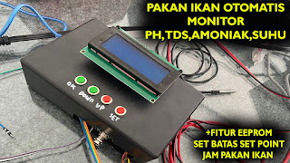

Pada kesempatan kali ini saya akan menjelaskan mengenai bagaimana cara membuat sebuah alat yang dapat memonitor PH,TDS/NTU,Amoniak,Suhu dan juga dapat memberikan pakan ikan otomatis pada jam-jam tertentu tergantung dari setting waktu pakannya. alat ini juga dilengkapi dengan EEPROM sehingga ketika lampu padam maka setting batasnya tidaklah menjadi 0 namun sesuai setting yang kita inputkan. untuk lebih jelasnya berikut adalah koding dan komponennya.

1. Komponennya:

a. Arduino Uno
b. Sensor PH
c. Turbidity Sensor
d. Sensor Ds18b20
e. Sensor HC-SRF04
f. Nodemcu ESP8266
g. Modul Relay 3 Channel
h. Mini Servo
i. LCD 20x4 + I2C
j. Push Button

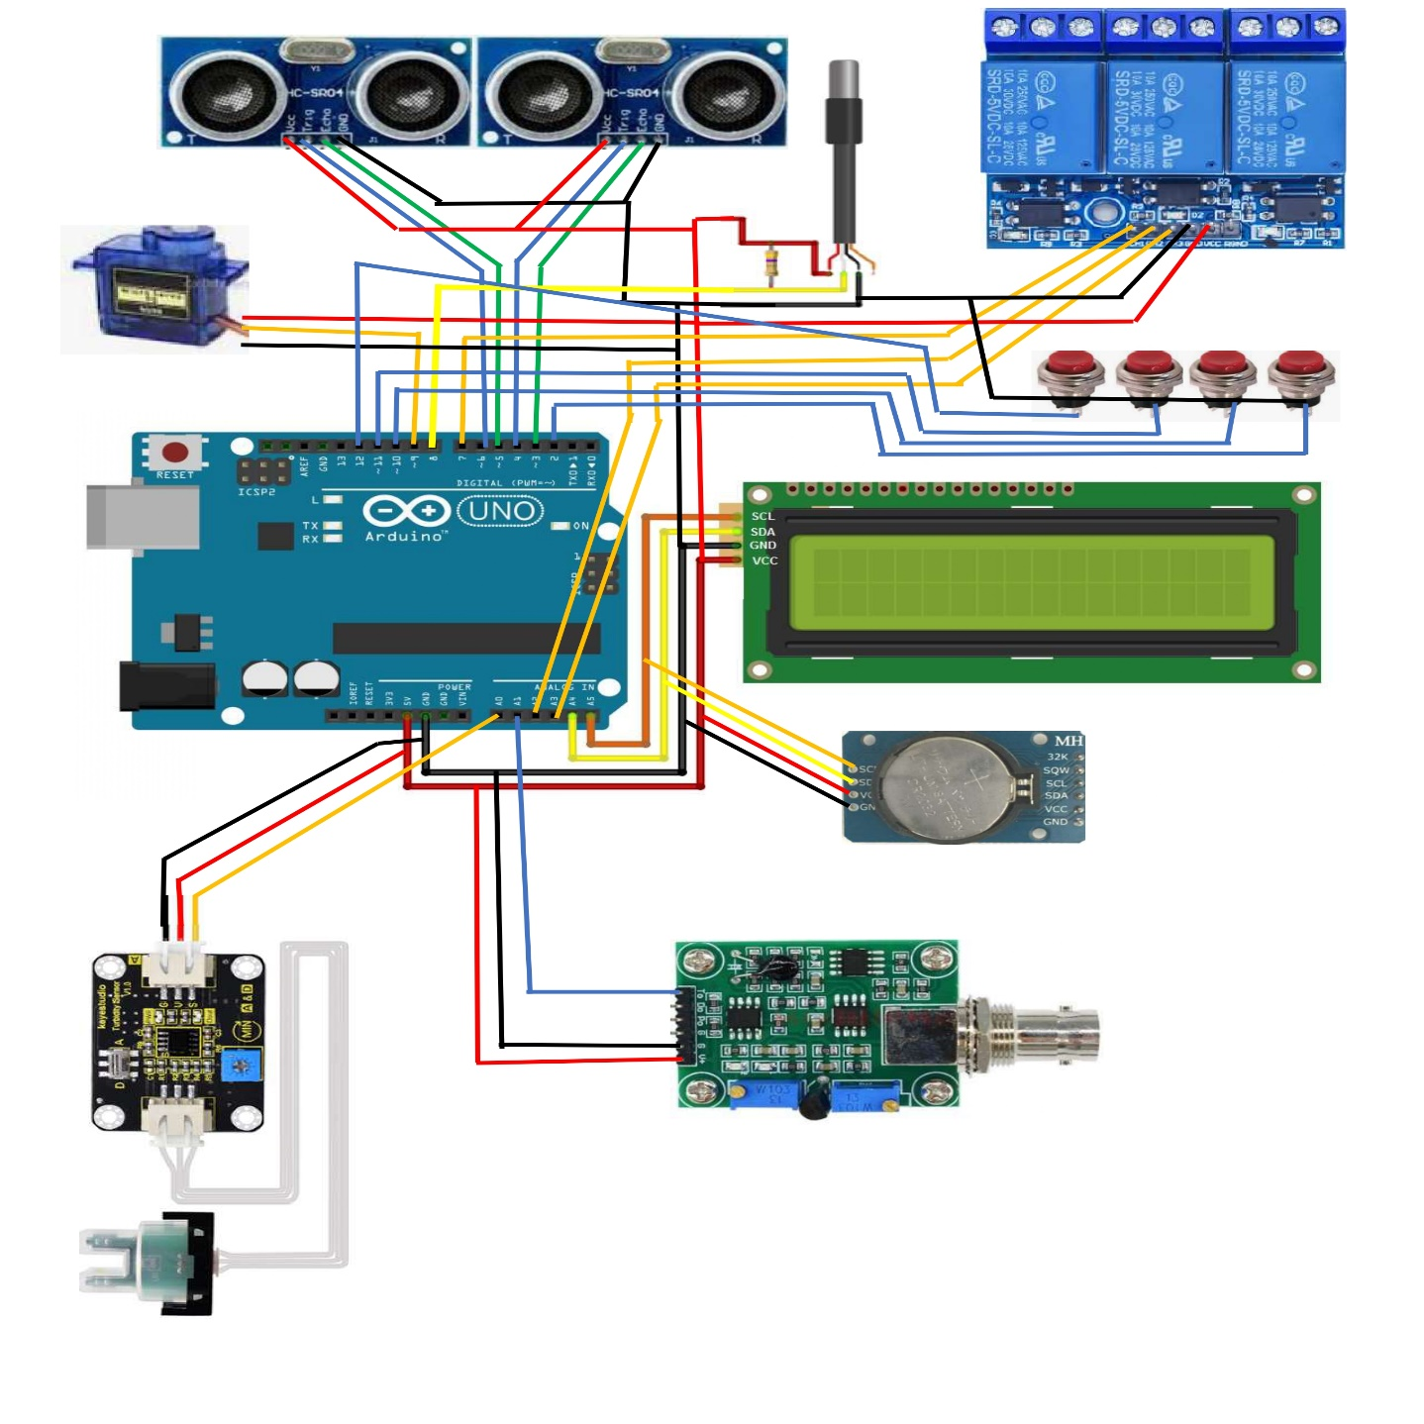

2. Program Arduino IDE

#include <Wire.h>
#include <OneWire.h>
#include <DallasTemperature.h>
#include <LiquidCrystal_I2C.h>
#include <DS3231.h>
#include <EEPROM.h>
#define ONE_WIRE_BUS 8
#include <Servo.h>

#define trigPin1 6
#define echoPin1 5
#define trigPin2 4
#define echoPin2 3

OneWire oneWire(ONE_WIRE_BUS);
DallasTemperature sensors(&oneWire);

LiquidCrystal_I2C lcd(0x27,20,4);
DS3231 rtc(SDA, SCL);
Servo myservo;

int addr1 = 0;
int addr2 = 1;
int addr3 = 2;
int addr4 = 3;
int addr5 = 4;

Time t;
int jampagi,jamsiang,jamsore;
float TempC;
float pHValue;
int tds;
int adctds;
int adcPH;
int TempCx;
int pHValuex;
int ntux;
float ntufix;
long duration1, distance1;
long duration2, distance2;
int btset = 2;
int btup = 10;
int btdown = 11;
int btok = 12;
int btsetx;
int btupx;
int btdownx;
int btokx;
float batasamo;
float batasph;
float amoniak;
int relayout = A3;
int relayin = A2;
int relayaerator = 7;
int tanda = 0;
int kolam;
int tinggipakan;

void setup(){

jampagi = EEPROM.read(addr1);
jamsiang = EEPROM.read(addr2);
jamsore = EEPROM.read(addr3);
batasamo = EEPROM.read(addr4);
batasph = EEPROM.read(addr5);

pinMode(relayout,OUTPUT);
pinMode(relayin,OUTPUT);
pinMode(relayaerator,OUTPUT);
digitalWrite(relayout,LOW);
digitalWrite(relayin,LOW);
digitalWrite(relayaerator,LOW);

pinMode(btset,INPUT_PULLUP);
pinMode(btup,INPUT_PULLUP);
pinMode(btdown,INPUT_PULLUP);
pinMode(btok,INPUT_PULLUP);

pinMode(trigPin1, OUTPUT);
pinMode(echoPin1, INPUT);
pinMode(trigPin2, OUTPUT);
pinMode(echoPin2, INPUT);

Wire.begin();
sensors.begin();
Serial.begin(9600);
lcd.begin();
lcd.clear();

rtc.begin();
//rtc.setDOW(WEDNESDAY); // Set Day-of-Week to SUNDAmy
//rtc.setTime(13, 15, 0); // Set the time to 12:00:00 (24hr format)
//rtc.setDate(1, 1, 2014); // Set the date to January 1st, 2014

myservo.attach(9);
myservo.write(100);
}

void loop(){

btsetx = digitalRead(btset);
btupx = digitalRead(btup);
btdownx = digitalRead(btdown);
btokx = digitalRead(btok);

if(btsetx == 0){
delay(1000);
lcd.clear();
setjampagi();
setjamsiang();
setjamsore();
setbatasamo();
setbatasph();
}

t = rtc.getTime();

//ketinggian air kolam
digitalWrite(trigPin1, LOW); // Added this line
delayMicroseconds(2); // Added this line
digitalWrite(trigPin1, HIGH);
delayMicroseconds(10); // Added this line
digitalWrite(trigPin1, LOW);
duration1 = pulseIn(echoPin1, HIGH);
distance1 = (duration1/2) / 29.1;

//ketinggian pakan ikan
digitalWrite(trigPin2, LOW); // Added this line
delayMicroseconds(2); // Added this line
digitalWrite(trigPin2, HIGH);
delayMicroseconds(10); // Added this line
digitalWrite(trigPin2, LOW);
duration2 = pulseIn(echoPin2, HIGH);
distance2 = (duration2/2) / 29.1;

if(distance1 > 35){
distance1 = 35;
}

if(distance2 > 30){
distance2 = 30;
}

kolam = 35 - distance1;
tinggipakan = map(distance2, 5,30,100,0);

if((kolam >= 29)&&(kolam <= 31)){
digitalWrite(relayin,LOW);
digitalWrite(relayout,LOW);
}

if(kolam < 29){
digitalWrite(relayin,HIGH);
digitalWrite(relayout,LOW);
}

if(kolam > 31){
digitalWrite(relayin,LOW);
digitalWrite(relayout,HIGH);
}

adcPH = analogRead(A0); //menggunakan pin A0 untuk membaca output sensor pH
pHValue = (adcPH - 906.84) / -37.283;

adctds = analogRead(A1);
tds = map(adctds, 855, 1, 0, 100);

pHValuex = pHValue * 100.0;

sensors.requestTemperatures();
TempC = sensors.getTempCByIndex(0); // Celcius
TempCx = TempC * 100.0;

if(pHValue < 6.5){
amoniak = (pHValue / TempC) * 0.202;
}

if(pHValue == 7.0){
amoniak = (pHValue / TempC) * 1.131;
}

if(pHValue > 7.0){
amoniak = (pHValue / TempC) * 3.306;
}

if(amoniak > batasamo){
digitalWrite(relayaerator,HIGH);
}

if(amoniak <= batasamo){
digitalWrite(relayaerator,LOW);
}

if((t.hour == jampagi)&&(jampagi > 0)&&(tanda == 0)){
myservo.write(150);
delay(5000);
myservo.write(100);
tanda = 1;
}

if((t.hour == jamsiang)&&(jamsiang > 0)&&(tanda == 1)){
myservo.write(150);
delay(5000);
myservo.write(100);
tanda = 2;
}

if((t.hour == jamsore)&&(jamsore > 0)&&(tanda == 2)){
myservo.write(150);
delay(5000);
myservo.write(100);
tanda = 0;
}

lcd.setCursor(0,0);
lcd.print("TDS:");
lcd.print(tds);
lcd.print("% ");

lcd.print("PH:");
lcd.print(pHValue);
lcd.print(" ");

lcd.setCursor(0,1);
lcd.print("T:");
lcd.print(TempC,1);
lcd.print("c ");

lcd.print(batasamo);
lcd.print("/");
lcd.print(batasph);
lcd.print(" ");

lcd.setCursor(0,2);
lcd.print(t.hour, DEC);
lcd.print(":");
lcd.print(t.min, DEC);
lcd.print(":");
lcd.print(t.sec, DEC);
lcd.print(" ");
lcd.print(jampagi);
lcd.print("/");
lcd.print(jamsiang);
lcd.print("/");
lcd.print(jamsore);
lcd.print(" ");

lcd.setCursor(0,3);
lcd.print("S=");
lcd.print(kolam);
lcd.print("/");
lcd.print(tinggipakan);
lcd.print(" ");

lcd.setCursor(10,3);
lcd.print("Mg/l:");
lcd.print(amoniak);
lcd.print(" ");

Serial.print("*");
Serial.print(pHValue * 100.0);
Serial.print(",");
Serial.print(tds);
Serial.print(",");
Serial.print(amoniak * 100.0);
Serial.print(",");
Serial.print(TempC * 100.0);
Serial.println("#");

delay(1000);
}

void setjampagi(){

btsetx = digitalRead(btset);
btupx = digitalRead(btup);
btdownx = digitalRead(btdown);
btokx = digitalRead(btok);

lcd.setCursor(0,0);
lcd.print("Waktu Pakan Pagi");
lcd.setCursor(0,1);
lcd.print("Jam: ");
lcd.print(jampagi);
lcd.print(" ");

if(btupx == 0){
delay(200);
jampagi++;
}

if(btdownx == 0){
delay(200);
jampagi--;
}

if(jampagi > 23){
jampagi = 0;
}

if(btokx == 0){
lcd.clear();
delay(2000);
EEPROM.write(addr1, jampagi);
return;
}

setjampagi();
}

void setjamsiang(){

btsetx = digitalRead(btset);
btupx = digitalRead(btup);
btdownx = digitalRead(btdown);
btokx = digitalRead(btok);

lcd.setCursor(0,0);
lcd.print("Waktu Pakan Siang ");
lcd.setCursor(0,1);
lcd.print("Jam: ");
lcd.print(jamsiang);
lcd.print(" ");

if(btupx == 0){
delay(200);
jamsiang++;
}

if(btdownx == 0){
delay(200);
jamsiang--;
}

if(jamsiang > 23){
jamsiang = 0;
}

if(btokx == 0){
lcd.clear();
delay(2000);
EEPROM.write(addr2, jamsiang);
return;
}

setjamsiang();
}

void setjamsore(){

btsetx = digitalRead(btset);
btupx = digitalRead(btup);
btdownx = digitalRead(btdown);
btokx = digitalRead(btok);

lcd.setCursor(0,0);
lcd.print("Waktu Pakan Sore ");
lcd.setCursor(0,1);
lcd.print("Jam: ");
lcd.print(jamsore);
lcd.print(" ");

if(btupx == 0){
delay(200);
jamsore++;
}

if(btdownx == 0){
delay(200);
jamsore--;
}

if(jamsore > 23){
jamsore = 0;
}

if(btokx == 0){
lcd.clear();
delay(2000);
EEPROM.write(addr3, jamsore);
return;
}

setjamsore();
}

void setbatasamo(){

btsetx = digitalRead(btset);
btupx = digitalRead(btup);
btdownx = digitalRead(btdown);
btokx = digitalRead(btok);

lcd.setCursor(0,0);
lcd.print("BATAS AMONIAK ");
lcd.setCursor(0,1);
lcd.print("mg/l: ");
lcd.print(batasamo);
lcd.print(" ");

if(btupx == 0){
delay(200);
batasamo = batasamo + 0.1;
}

if(btdownx == 0){
delay(200);
batasamo = batasamo - 0.1;
}

if(batasamo > 100.0){
batasamo = 0;
}

if(btokx == 0){
lcd.clear();
delay(2000);
EEPROM.write(addr4, batasamo);
return;
}

setbatasamo();
}

void setbatasph(){

btsetx = digitalRead(btset);
btupx = digitalRead(btup);
btdownx = digitalRead(btdown);
btokx = digitalRead(btok);

lcd.setCursor(0,0);
lcd.print("BATAS PH ");
lcd.setCursor(0,1);
lcd.print("PH: ");
lcd.print(batasph);
lcd.print(" ");

if(btupx == 0){
delay(200);
batasph = batasph + 0.1;
}

if(btdownx == 0){
delay(200);
batasph = batasph - 0.1;
}

if(batasph > 100.0){
batasph = 0;
}

if(btokx == 0){
lcd.clear();
delay(2000);
EEPROM.write(addr5, batasph);
return;
}

setbatasph();
}

3. Program Nodemcu ESP8266

#include <ESP8266WiFi.h>
#include <ThingSpeak.h>
#include <WiFiClient.h>

int temp;
int x = 5;
int y;

int value1;
int value2;
int value3;
int value4;

float ph;
int tds;
float amoniak;
float suhu;

int datain1;
int datain2;
int datain3;
int datain4;

String dataIn;
String dt[10];
int i;
boolean parsing = false;

String apiKey = "UYGFUY87JKJGJ6HKS"; // Enter your Write API key from ThingSpeak
const char* resource = "/update?api_key=";

const char* ssid = "hotspothpku"; // replace with your wifi ssid and wpa2 key
const char* pass = "123456789";
const char* server = "api.thingspeak.com";

WiFiClient client;

void setup()
{

dataIn="";
Serial.begin(9600);
delay(10);

Serial.print("Connecting to ");
Serial.println(ssid);

WiFi.begin(ssid, pass);

while (WiFi.status() != WL_CONNECTED) {
delay(500);
Serial.print(".");
}
Serial.println("");
Serial.println("WiFi connected");

while (WiFi.status() != WL_CONNECTED)
{
delay(500);
Serial.print(".");
}
Serial.println("");
Serial.println("WiFi connected");

}

void loop()
{

while(Serial.available()>0) {
// dataIn="";
char inChar = (char)Serial.read();
dataIn += inChar;
if (inChar == '\n') {
parsing = true;
}
}

if(parsing){
parsingData();

if (client.connect(server,80)) // "184.106.153.149" or api.thingspeak.com
{

String postStr = apiKey;
postStr +="&field1=";
postStr += String(ph);
postStr += "\r\n\r\n";

client.print(String("GET ") + resource + apiKey + "&field1=" + ph + "&field2=" + tds + "&field3=" + amoniak + "&field4=" + suhu + " HTTP/1.1\r\n" + "Host: " + server + "\r\n" + "Connection: close\r\n\r\n");

client.print("Host: api.thingspeak.com\n");
client.print("Connection: close\n");
client.print("X-THINGSPEAKAPIKEY: "+apiKey+"\n");
client.print("Content-Type: application/x-www-form-urlencoded\n");
client.print("Content-Length: ");
client.print(postStr.length());
client.print("\n\n");
client.print(postStr);

Serial.println(". Send to Thingspeak.");
}

client.stop();

//Serial.println("Waiting...");

delay(10000);

}
}

void parsingData(){
int j=0;

//kirim data yang telah diterima sebelumnya
//Serial.print("data masuk : ");
//Serial.print(dataIn);
//Serial.print("\n");

//inisialisasi variabel, (reset isi variabel)
dt[j]="";
//proses parsing data
for(i=1;i<dataIn.length();i++){
//pengecekan tiap karakter dengan karakter (#) dan (,)
if ((dataIn[i] == '#') || (dataIn[i] == ','))
{
//increment variabel j, digunakan untuk merubah index array penampung
j++;
dt[j]=""; //inisialisasi variabel array dt[j]
}
else
{
//proses tampung data saat pengecekan karakter selesai.
dt[j] = dt[j] + dataIn[i];
}
}

datain1 = dt[0].toInt();
datain2 = dt[1].toInt();
datain3 = dt[2].toInt();
datain4 = dt[3].toInt();

//kirim data hasil parsing
Serial.print("data 1 : ");
Serial.print(datain1);
Serial.print("\n");
Serial.print("data 2 : ");
Serial.print(datain2);
Serial.print("\n");
Serial.print("data 3 : ");
Serial.print(datain3);

ph = datain1 / 100.0;
tds = datain2 / 1;
amoniak = datain3 / 100.0;
suhu = datain4 / 100.0;

}

